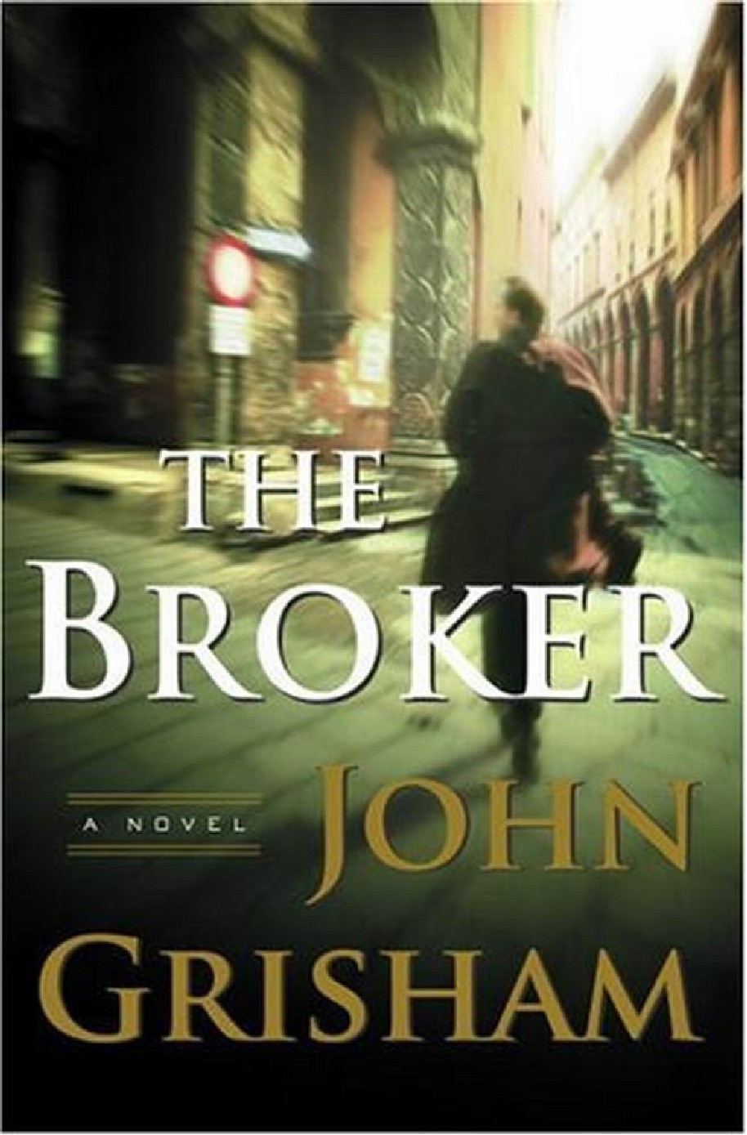
John Grisham
The Broker
The Broker
John Grisham
-1-
John Grisham
The Broker
A Time to Kill
The Firm The Pelican Brief
The Client
The Chamber
The Rainmaker
The Runaway Jury
The Partner
The Street Lawyer
The Testament
The Brethren
A Painted House
Skipping Christmas
The Summons The King of Torts
Bleachers The Last Juror
-2-
John Grisham
The Broker
John
Grisham
-3-
John Grisham
The Broker
Doubleday
New York London Toronto Sydney Auckland
-4-

